**Monitoring tools - grafana and prometheus**

Step 1:-

Grafana installation link for Windows:-

Link:- https://grafana.com/docs/grafana/latest/installation/windows/

Prometheus installation link for Windows:-

Link:- https://prometheus.io/download/

NSSM installation link for Windows:-

Link:- https://nssm.cc/download

Install NSSM - (the Non-Sucking Service Manager) for service helper programs suck because they don't handle failure of the application running as a service

Step 2:-

Install Grafana and prometheus using command line

Syntax:- *nssm install <servicename> <program> [<arguments>]*

*Example:- nssm install Grafana "C:\Users\devops\Downloads\grafana-6.0.0-beta1.windows-amd64\grafana-6.0.0-beta1\bin\grafana-server.exe"*

*[use same process to install prometheus]*

*Step 3:- You can see Grafana and Prometheus services in services.msc*

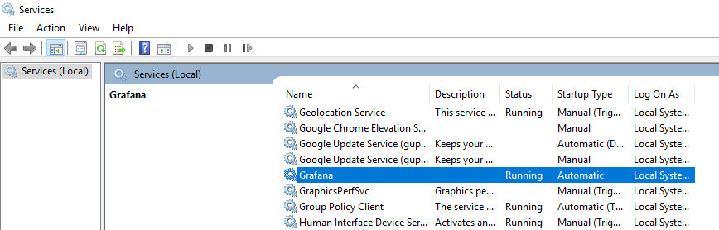

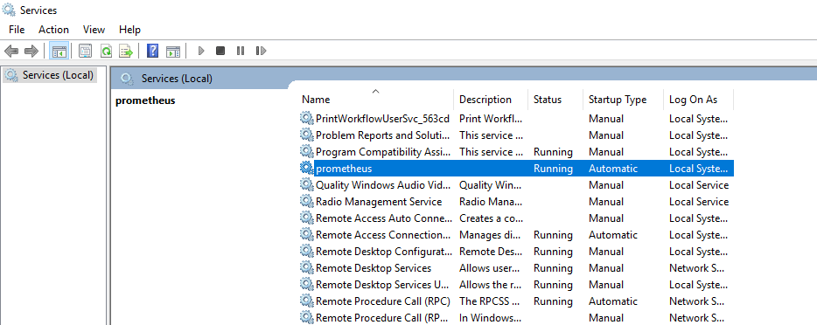

Step 4:-

Now we can use Grafana and Prometheus using below url using systems IP address or localhost.

Grafana:- http://192.168.11.173:3000/

Prometheus:-http://192.168.11.173:9090/

**Note:-** default username and password for Grafana is **admin**.